

Department of Electronics and Computers
Study programme: Applied Electronics

Verification Project
Interrupt Controller

Table of Contents
1 Digital Design of the Circuit 3
1.1 Block Diagram 3
1.2 General Functionality Description of the DUT 3
1.3 DUT Interfaces 4
1.4 List of DUT Functionalities 5
1.5 Waveforms 6
1.6 Register Table 7
2 Digital Circuit Project Verification 13
2.1 Verification Environment Arhitecture 13
2.1.1 APB Generator 14
2.1.2 APB Driver 14
2.1.3 APB Monitor 14
2.1.4 Output Interface Monitor 15
2.1.5 Transaction for APB Interface 15
2.1.6 Transaction for Output Interface 15
2.1.7 Scoreboard/Reference Model 15
2.2 List of Elements to be Verified 15
2.3 Functional Coverage Elements 17
2.4 Tests 18
2.5 Obtained Results 18

Digital Design of the Circuit
Block Diagram
General functionality description of the DUT
DUT interfaces
List of DUT functionalities
Schematic diagram
Waveforms
Register table

Block Diagram
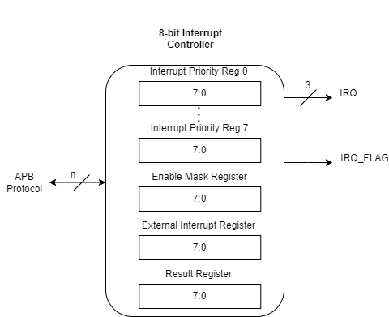
Figure 1. Block diagram of the interrupt controller

General Functionality Description of the DUT

The DUT receives the APB interface as input and, based on the 10 configuration registers, provides as output the binary code associated with the interrupt channel number that needs to be serviced. The irq_flag signal indicates the occurrence of an interrupt and validates the output data.

DUT Interfaces

Table 1. Signals within the APB data transmission interface
APB Interface
Signal Name | Bit Width | Direction | Description
psel | 1 | Input | Selection signal
penable | 1 | Input | Enable signal. This signal indicates the second cycle of an APB transfer
pwrite | 1 | Input | Transfer direction. This signal indicates a write access when high and a read access when low
paddr | 6 | Input | Transfer address
pwdata | 32 | Input | Data to be written
prdata | 32 | Output | Data to be read
pready | 1 | Output | Ready signal. The slave can use this signal to extend a transfer
pslverr | 1 | Output | Error signal. This signal indicates a failed transfer

APB transfers are completed in two clock cycles if no wait states are introduced and consist of two phases: setup and access.
- In the setup phase, paddr and pwdata are set by the Master device.
- psel and pwrite are asserted to indicate that the Slave device is selected and that the access type is a write.
- In the access phase, the Master asserts penable, and the Slave responds with pready to signal that the access has been completed.

Table 2. Signals within the output interface
Output Interface
Signal Name | Bit Width | Direction | Description
irq | 3 | Output | Binary code of the active interrupt channel
irq_flag | 1 | Output | Pulse signal validating the irq output

List of DUT Functionalities
- In the Interrupt Priority Registers, the value 0 is reserved for unconfigured states.
- In the Enable Mask Register, the value 1 signifies the validation of the respective input.
- The APB register write interface writes 8 bits per call.
- The unmasked interrupt servicing phase begins after all priority registers have been configured and the register representing the input applied to the DUT (EXT_INT) is set.
- The active interrupt servicing ends after serving the last validated input in terms of priority. To start a new servicing cycle, a new value must be written to the EXT_INT register. This clears the internal served-interrupts mask and allows the controller to re-evaluate all enabled, asserted interrupts by priority.
- For the APB interface, the RESULT register is read-only and can only be written to within the DUT.
- The output validation signal (IRQ_FLAG) is pulse-based.

- DUT Parameters:
  - ADDR_WIDTH: Address length (in bits)
  - DATA_WIDTH: Data length (in bits)
  - IRQ_WIDTH: Interrupt length (in bits)
- Issues encountered during DUT design:
  - Traversing all interrupt priorities using a for loop.
  - Solution: Implementing an FSM (Finite State Machine) for each priority register.
- Limitations in DUT operation:
  - pready is generated combinationally as psel AND penable, meaning it becomes active in the same clock cycle as penable during the access phase.
The DUT implements a three-state FSM: WAIT, PROCESS, and VALIDATE. Within the PROCESS state, a sub-FSM scans all 8 priority registers sequentially (PRI0 through PRI7), followed by a DECIDE state. The DECIDE state allows the final non-blocking assignment from PRI7 to settle before determining whether an eligible interrupt exists. If a valid interrupt is found, the FSM transitions to VALIDATE, which outputs the interrupt code and asserts IRQ_FLAG for one clock cycle. If no eligible interrupt is found, the FSM returns to WAIT.

Waveforms

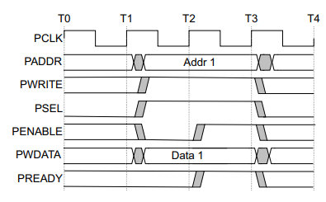
Figure 2. Waveforms for a write transfer using the APB interface

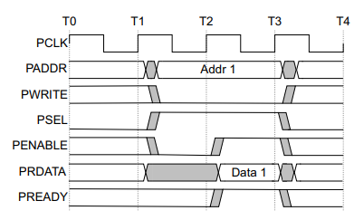
Figure 3. Waveforms for a read transfer using the APB interface

Register Table
The configuration registers are:
- Interrupt Priority Registers – A set of 8 registers, each 8 bits wide, containing the priority of the external channel on a scale from 1 to 8. The values recorded for the 8 sources cannot be equal.
- Enable Mask Register – An 8-bit register containing the validation mask for the inputs.
- Result Register – An 8-bit register that is updated with every change of the outputs.
- External Interrupt Register – An 8-bit register, one for each input. The values of the 8 interruptible channels received by the DUT through the APB interface are stored in this register.
Writes to the registers are performed per byte. For 8-bit registers, the APB protocol is instantiated only once.

Table 3. Registers Accessible by the DUT
Register Name | Access Address | Register Structure | Register Description
INT_PRI0 | 0x01 | 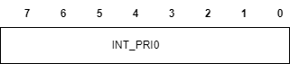 | This register contains the priority of input 0 of the module
INT_PRI1 | 0x02 | 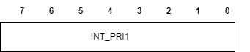 | This register contains the priority of input 1 of the module
INT_PRI2 | 0x03 | 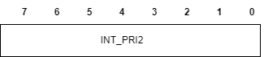 | This register contains the priority of input 2 of the module
INT_PRI3 | 0x04 | 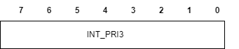 | This register contains the priority of input 3 of the module
INT_PRI4 | 0x05 | 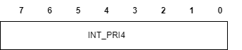 | This register contains the priority of input 4 of the module
INT_PRI5 | 0x06 | 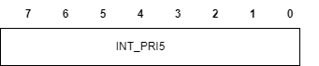 | This register contains the priority of input 5 of the module
INT_PRI6 | 0x07 | 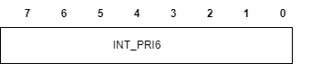 | This register contains the priority of input 6 of the module
INT_PRI7 | 0x08 | 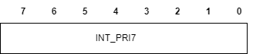 | This register contains the priority of input 7 of the module
EXT_INT | 0x09 | 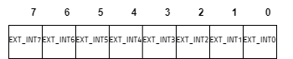 | This register contains the values of the 8 interrupt inputs
RESULT | 0x10 | 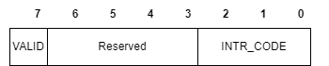 | This register contains the values of the module’s two outputs. It is written on every output update.
EN_MASK | 0x11 | 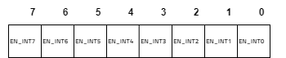 | This register indicates which inputs are activated and which are ignored (mask functionality register).

Table 4. Interrupt Enable Mask Register
Field | Name | Register Type | Reset Value | Field Description
31:8 | RESERVED
7 | EN_INT7 | RW | 1’b0 | 1: enabled  0: disabled
6 | EN_INT6 | RW | 1’b0 | 1: enabled  0: disabled
5 | EN_INT5 | RW | 1’b0 | 1: enabled  0: disabled
4 | EN_INT4 | RW | 1’b0 | 1: enabled  0: disabled
3 | EN_INT3 | RW | 1’b0 | 1: enabled  0: disabled
2 | EN_INT2 | RW | 1’b0 | 1: enabled  0: disabled
1 | EN_INT1 | RW | 1’b0 | 1: enabled  0: disabled
0 | EN_INT0 | RW | 1’b0 | 1: enabled  0: disabled

Table 5. Interrupt Priority0 Register Configuration
Field | Name | Register Type | Reset Value | Field Description
31:8 | REZERVAT
7:0 | INT_PRI0 | RW | 8’b0000_0000 | This register contains the priority value of interrupt code 0 (between 1 and 8)

Table 6. Interrupt Priority1 Register Configuration
Field | Name | Register Type | Reset Value | Description
31:8 | RESERVED
7:0 | INT_PRI1 | RW | 8’b0000_0000 | This register contains the priority value of interrupt code 1 (between 1 and 8)

Table 7. Interrupt Priority2 Register Configuration
Field | Name | Register Type | Reset Value | Description
31:8 | RESERVED
7:0 | INT_PRI2 | RW | 8’b0000_0000 | This register contains the priority value of interrupt code 2 (between 1 and 8)

Table 8. Interrupt Priority3 Register Configuration
Field | Name | Register Type | Reset Value | Description
31:8 | RESERVED
7:0 | INT_PRI3 | RW | 8’b0000_0000 | This register contains the priority value of interrupt code 3 (between 1 and 8)

Table 9. Interrupt Priority4 Register Configuration
Field | Name | Register Type | Reset Value | Description
31:8 | RESERVED
7:0 | INT_PRI4 | RW | 8’b0000_0000 | This register contains the priority value of interrupt code 4 (between 1 and 8)

Table 10. Interrupt Priority5 Register Configuration
Field | Name | Register Type | Reset Value | Description
31:8 | RESERVED
7:0 | INT_PRI5 | RW | 8’b0000_0000 | This register contains the priority value of interrupt code 5 (between 1 and 8)

Table 11. Interrupt Priority6 Register Configuration
Field | Name | Register Type | Reset Value | Description
31:8 | RESERVED
7:0 | INT_PRI6 | RW | 8’b0000_0000 | This register contains the priority value of interrupt code 6 (between 1 and 8)

Table 12. Interrupt Priority7 Register Configuration
Field | Name | Register Type | Reset Value | Description
31:8 | RESERVED
7:0 | INT_PRI7 | RW | 8’b0000_0000 | This register contains the priority value of interrupt code 7 (between 1 and 8)

Table 13. External Interrupt Register
Field | Name | Register Type | Reset Value | Description
31:8 | RESERVED
7 | EXT_INT7 | RW | 1’b0 | This register contains the value associated with input 7
6 | EXT_INT6 | RW | 1’b0 | This register contains the value associated with input 6
5 | EXT_INT5 | RW | 1’b0 | This register contains the value associated with input 5
4 | EXT_INT4 | RW | 1’b0 | This register contains the value associated with input 4
3 | EXT_INT3 | RW | 1’b0 | This register contains the value associated with input 3
2 | EXT_INT2 | RW | 1’b0 | This register contains the value associated with input 2
1 | EXT_INT1 | RW | 1’b0 | This register contains the value associated with input 1
0 | EXT_INT0 | RW | 1’b0 | This register contains the value associated with input 0

Table 14. Result Register (Stores Output Interface Values)
Field | Name | Register Type | Reset Value | Description
31:8 | RESERVED
7 | VALID | RO | 1’b0 | Set to 1’b1 when an interrupt is validated
6:3 | RESERVED
2:0 | INTR_CODE | RO | 3’b000 | Contains the binary code associated with the validated interrupt

Digital Circuit Project Verification
Verification environment architecture
List of elements to be verified
Functional coverage elements
Tests
Obtained results

Verification Environment Arhitecture

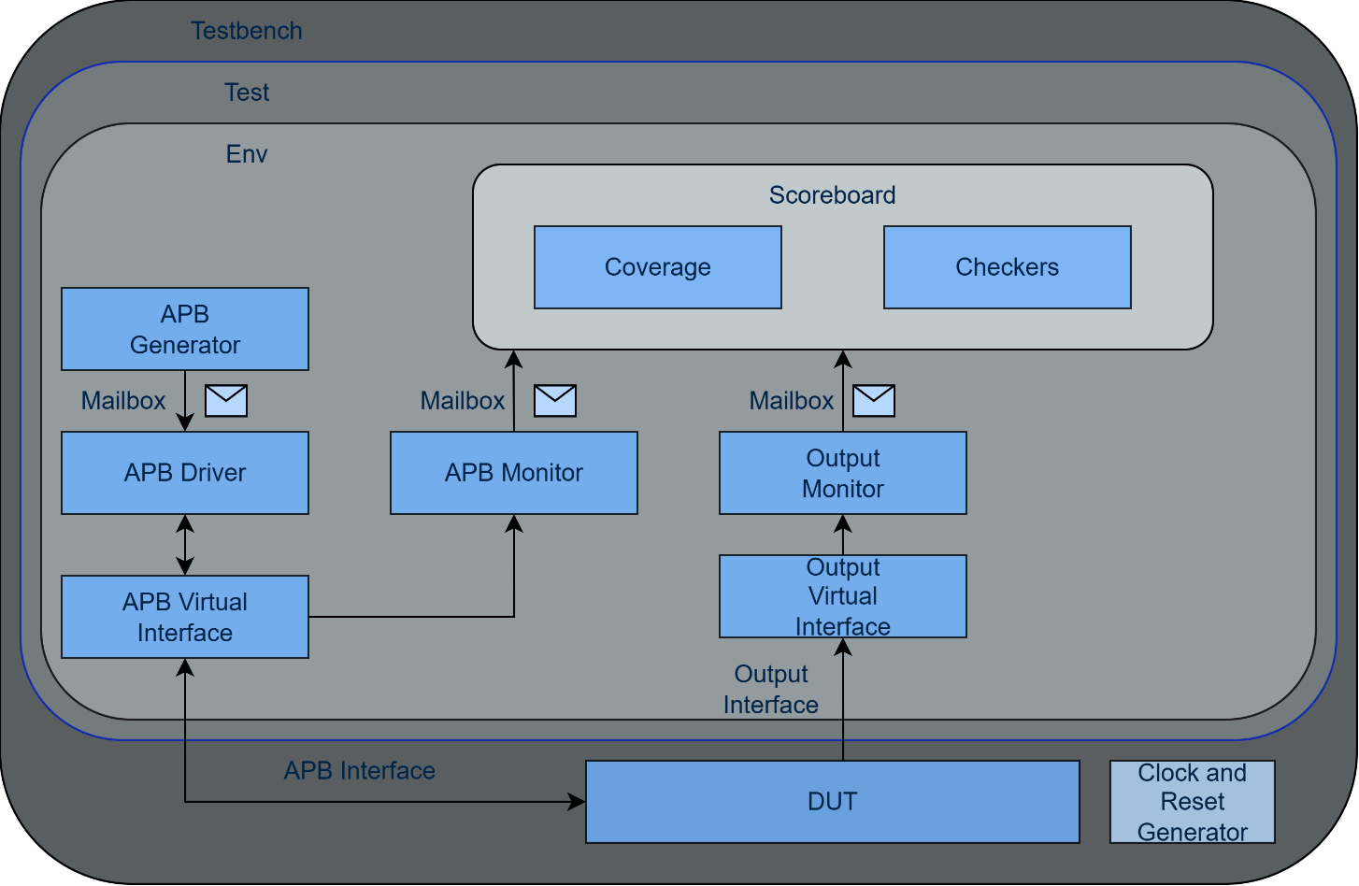
Figure 4. Block diagram of the verification environment

APB Generator
The APB generator randomly generates APB write/read transactions and sends them through a mailbox to the driver.

APB Driver
This component receives transactions from the mailbox and transmits signals to the interface according to the protocol.

APB Monitor
After each transaction sent on the APB interface, the monitor collects signals from the interface and packages them into transactions, which are then sent to the scoreboard. The interface signal that triggers the packaging process is PSEL.

Output Interface Monitor
After each transaction sent on the output interface, the monitor checks the signals and packages them into transactions that are later sent to the scoreboard.
Transactions are retrieved from the interface when the irq_flag signal is active.

Transaction for APB Interface

The transaction class for the APB interface contains the following fields, which can be randomly generated and sent to the DUT:
- rand bit [5:0] addr
- rand bit [7:0] data
- rand int delay
- rand apb_kind_t kind

Transaction for Output Interface
The transaction class for the output interface contains the following fields, which can be randomized and sent to the DUT:
- rand bit [2:0] irq

Scoreboard/Reference Model
This component contains a prediction model for the DUT's activity. It receives transactions from both the APB interface and the output interface, predicts the expected values of the DUT's registers and outputs, and compares the DUT's actual outputs with the predicted values.
The scoreboard maintains an internal served-interrupts mask to track which interrupts have already been output by the DUT during the current servicing cycle. It uses a priority-based ordering algorithm (order_interrupts) that ranks enabled, pending, and unserved interrupts from highest to lowest priority. After each DUT output event, the scoreboard recomputes its prediction to account for the updated served-interrupts state. A pipeline hazard detection mechanism accounts for the DUT's multi-cycle priority scanning window: if a register write occurs within 12 clock cycles of a DUT output, mismatches are reported as warnings rather than errors.

List of Elements to be Verified

Checker | Description
reg_result_check | Checks whether the result register has the same values as the outputs.
irq_order_check | Checks whether interrupts have been serviced in order of priority.
irq_mask_check | Verifies that the serviced interrupts had their respective bits asserted in the ENABLE_MASK register.

APB Assertions | Description
PSEL_PENABLE | Any rising edge of the psel signal implies a rising edge for the penable signal.
PWDATA_WHILE_WRITE | Specifies that the pwdata write data signal must remain stable (unchanged) during a write operation (when pwrite, psel, and penable are 1).
PADDR_STABLE | Ensures address integrity during transfers on the APB bus by verifying that the address sent by the master to the slave device does not change during the transaction.
PRDATA_WHILE_READ | Verifies that the prdata read data signal does not contain undefined values (X) during a read operation (when pwrite is low, psel is high, and pready is high).
PSEL_DEFINED_STATE | Ensures that the peripheral select signal (psel) does not enter an undefined state (1’bx) or high impedance state (1’bz). It must always have a well-defined logic level (0 or 1).
PSEL_PREADY | Helps verify correct synchronization between the psel (peripheral select) and pready (availability) signals on the APB bus. Ensures that the peripheral completes its current operation before being selected for a new operation.
PSEL_PENABLE_FELL | Verifies that the penable signal is deactivated immediately after the peripheral is deselected.
PREADY_ONE_PULSE | Ensures that the pready signal remains active for only one clock cycle.
PREADY_DEFINED_STATE | Ensures that when a peripheral is selected and active (psel = 1, penable = 1), the pready signal has a defined value (0 or 1).
PENABLE_AFTER_PREADY | Verifies that the penable signal can only transition from low to high when the psel signal is already asserted, ensuring proper APB protocol sequencing.
PWRITE_DEFINED_STATE | Ensures that the pwrite signal (read/write generated by the master) is always in a defined state, avoiding misinterpretations and potential incorrect operations at the bus level.
PSEL_PENABLE_O | Ensures that when the psel signal rises (beginning the setup phase), the penable signal is not yet asserted, guaranteeing proper APB two-phase transfer sequencing.

Output Validation Assertions | Description
IRQ_FLAG_PULSE | Ensures that the interrupt controller's output validation signal is a pulse signal.

Functional Coverage Elements
Coverage elements for APB transactions:
Cover Group: apb_transaction_cg
Cover Point | Description
kind_cov | Both types of transactions (Read, Write) have been recorded.
addr_cov | Transactions have been recorded at all DUT register addresses.
data_cov | Data values between 0 and 255 have been recorded, covering different values in the specified range.

Coverage elements for the output transaction:
Cover Group: out_transaction_cg
Cover Point | Description
interrupt_cov | All possible interrupt codes (0 to 7) have been recorded on the output interface.

Tests

Table 5. List of implemented tests for DUT verification
Test File Name | Test Description
all_intr_en_test.sv | Simulates the configuration of all interrupts, with no masked inputs and all inputs active.
one_intr_en_test.sv | Simulates the configuration of all interrupts, with only one unmasked and active input.
random_test.sv | The registers mentioned above are configured randomly.
write_read_reg_test.sv | Checks the integrity of data written to registers.
addr_invalid_test.sv | Verifies read/write operations at invalid addresses.

Obtained Results
Each test was executed independently in Vivado behavioral simulation. All tests completed without assertion failures. The functional coverage results are summarized in the table below.
Table 6. Coverage results per test
Test Name | Address Coverage (%) | Data Coverage (%) | Operation Type Coverage (%) | Interrupt Code Coverage (%)
all_intr_en_test.sv | 71.43 | 69.23 | 50.00 | 100.00
one_intr_en_test.sv | 71.43 | 61.54 | 50.00 | 12.50
random_test.sv | 71.43 | 76.92 | 50.00 | 37.50
write_read_reg_test.sv | 78.57 | 100.00 | 100.00 | 100.00
addr_invalid_test.sv | 7.14 | 23.08 | 100.00 | 0.00

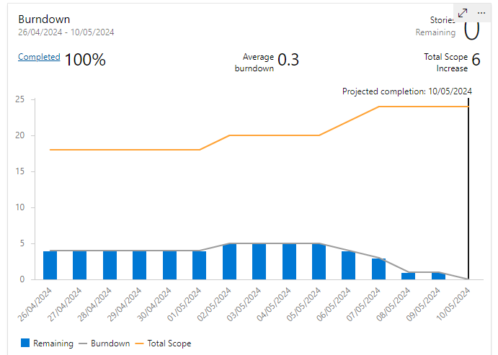 Progress on Task Completion

